Otaku Culture's Impact on the Mobile Role-Playing Game (RPG) Popularity: An Analytical Exploration of Trends and Influences in the Modern Digital Age

Anny Cui

The University of Puget Sound, Tacoma, WA, USA

December 12th, 2023

Abstract

Otaku culture, originally a niche interest centered around Japanese anime and manga, has undergone a remarkable evolution, transitioning into a globally recognized phenomenon with significant economic implications. The role of digital connectivity and globalization accelerates cultural effects on specific digital entertainment consumptions. This paper examines the influence of otaku culture proliferation on the popularity and economic success of mobile Role-Playing Games (RPGs) in the modern age.

Utilizing panel data from 30 countries (2016-2022), we employ linear and exponential models to analyze whether there exists a correlation between the otaku culture, quantified by anime and manga market, and mobile RPG market performance reflected by revenue and download, considering variables like GDP and mobile penetration. Findings indicate that the otaku culture statistically significantly impacts consumer behavior and market trends in mobile RPG industry, reflecting a nuanced symbiosis between cultural affinity and economic dynamics. This paper contributes to the understanding of how cultural phenomena like otaku culture shape market dynamics and consumer preferences in the digital age.

**Keywords:** Otaku Culture, Anime, Manga, Mobile Role-Playing Games, Globalization, Digital Entertainment, Cultural Trends, Quantitative Analysis, Consumer Behavior.

# **Introduction**

The surge of the otaku culture, a term signifying a passionate interest in Japanese anime and manga, has transcended its niche boundaries to influence global entertainment markets. Role-Playing Games (RPGs) resonate strongly with the themes and aesthetics commonly found in the otaku culture anime/manga stories. The deep narratives, character development, and fantasy worlds that are characteristic of both anime/manga and RPGs create a natural affinity between the two. This cultural alignment makes RPGs appealing to otaku enthusiasts.

The otaku culture, historically marginalized in Japan, has undergone a significant transformation. From the beginning, Garg (2019) stated that "otaku" (お宅) derived from a Japanese term for a person's house or family (宅, taku, home), initially referred to individuals inclined towards indoor hobbies.. While nowadays this term is defined as fervent enthusiasts of purchasing anime and manga. This shift, from a term denoting introversion to one symbolizing enthusiastic consumption, mirrors the evolution from personal amusement to a significant driver of economic activities, attracting a diverse international audience.

The global proliferation of the otaku culture has been accelerated by digital connectivity, with the internet and social media playing pivotal roles. Lamarre (2018) posited that television, animation, and game media are not isolated entities but often influence and shape each other. This global spread is further reinforced through collaborations between public and academic institutions in events like Anime and Comics Enthusiasts Conventions (ACEcon) (Knipp, Walker, Durney, and Perez, 2015). More and more people can access online to see the information of anime conventions. Deriving from sharing anime DVDs and manga volumes, where the practice of cosplay — dressing up as beloved characters from anime/manga to attend events (Kam, 2013) — has become a defining feature. These conventions also function as both social and commercial hubs, facilitating deeper engagement with anime and manga-related products, including games. Hernández-Pérez (2019) articulated how these conventions act as microcosms of the otaku culture, encapsulating fans’ sociocultural engagement and influencing a global transmedia industry.

Similar to the popularity of Hollywood and K-pop, the concept of globalization has dramatically altered the dynamics of otaku culture. Matusitz and Payano (2012) and Pookulangara and Koesler (2013) explored how Hollywood extended its influence from local to global markets through shooting films. This mirrors the impact of Hollywood on fashion trends, providing an analogy for understanding the otaku role-playing activities' influence on the mobile gaming genre industry. Patrick and Wonkyu (2017) offer insights into how specific cultural products, like K-pop, appeal globally, akin to the integration of anime and manga elements in gaming. Zhang et al. (2020) concluded that people who consumed K-pop music would also purchase other Korean products. They created a model to see that people who spent more frequently on K-pop would have a higher purchase intention on Korean imports. The appeal of K-pop has led to a broader appreciation and adoption of Korean culture and products, a parallel that can be drawn with the influence of the otaku culture on the mobile RPG market. Hills and McGregor (2002) illustrated that Japanese anime and manga have encouraged and fostered a global fan culture through role-playing activities. The "cool" fashion of immersive world role-playing in the otaku culture drove consumer engagement and spending within the mobile RPG sector (Niu, H.-J., Chiang, Y.-S., & Tsai, H.-T., 2012). This notion of transcultural fan fashion and the transnational flow of anime and manga are crucial in understanding the spread of the otaku culture across borders and its impact on global mobile RPG selling. The intersection of the otaku culture with the mobile RPG industry represents more than a mere overlap; It represents a symbiotic relationship of cultural impact on purchasing specific products.

The economic influence of otaku culture is multifaceted, impacting not only event expenditures but also the broader digital entertainment industry. Adams (2022) indicated that the otaku engagement succeeded in mobile RPG games like *Genshin Impact*. According to Chapple (2021) and Blake (2023), *Genshin Impact* has generated approximately $2 billion in global player spending on the App Store and Google Play since its official launch on September 28, 2020. Defined by immersive worlds and character-driven storylines, RPGs offer a fertile ground for anime-manga-based role-playing activities, which are cornerstones of the otaku culture.

Historically, research on the influence of various cultures on consumption economic activity often prioritized qualitative methodologies, notably interviews and surveys. Also, most previous studies theoretically provide conceptual frameworks to summarize and then analyze cultural phenomena. In contrast to previous research, this study emphasizes a global quantitative approach with panel data, spanning 30 countries which have observed market data and tracking dynamic trends from 2016 to 2022. This methodology aims to empirically capture the influence of otaku culture on mobile RPG popularity and market trends through quantified models. The study will delve into various aspects, like anime/manga conventions, sales, revenues, and the accessibility of anime, offering a comprehensive view of global cultural trends.

The otaku culture has evolved into a transmedia powerhouse. The proliferation of this culture has become a global phenomenon, transcending its Japanese origins and permeating the fabric of international media and entertainment industries. As a reflection of this cultural diffusion, mobile Role-Playing Games (RPGs) have seen a notable potential in economic success. This study seeks to unfold the otaku culture's economic impacts on the mobile RPG market, particularly focusing on how this cultural wave affects game popularity, as reflected in revenue and downloads.

# **Data**

In this section, we present the dataset and its sources used in this research, and then describe the variable selection for model methods applied to the data.

## 2.1 Data Description

This study aggregates data from a diverse range of sources to investigate the influence of the otaku culture on the mobile RPG game popularity and adoption. Table 1 below describes all variables in the dataset. We employ panel data, monitoring the mobile game and anime/manga market dynamics across from 2016 to 2022 in 30 countries, listed in Table 2. The research employs reports from Newzoo, Sensor Tower, and Statista, involving tracking the top 50 mobile game apps and the top 30 RPG apps. These reports provide RPG revenue and download data in different countries. Their primary mobile game data sources rely on game app tracking e-tools such as data.ai, business of apps, and AppMagic. In addition, for an accurate representation of anime/manga popularity, the research incorporates data from websites like animecons, market splash, myAnimeList, and Crunchyroll. Also, crucial economic indicators from World Bank World Development Indicators, such as GDP, GDP per capita, and mobile cellular subscriptions are also incorporated, resulting in a raw data of 210 observations in use. Descriptive statistics for these variables appear in Table 3.

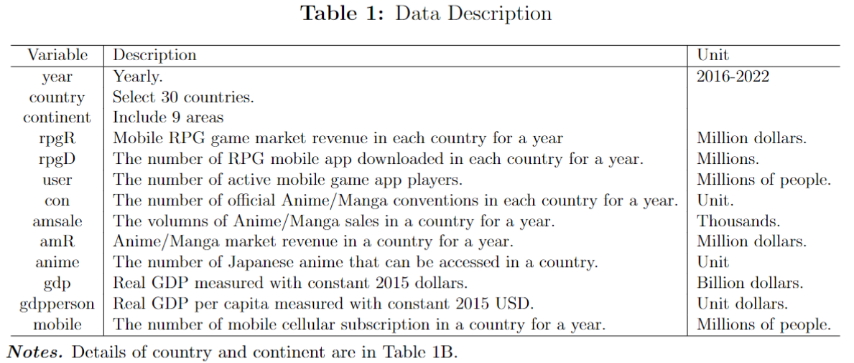

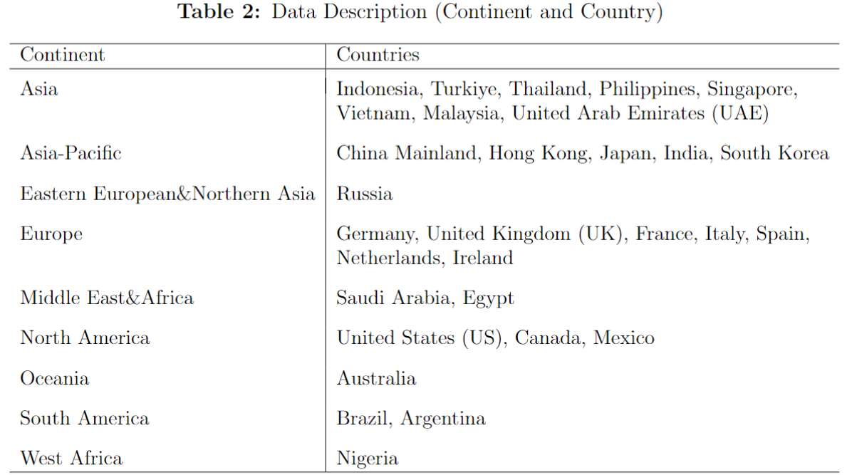

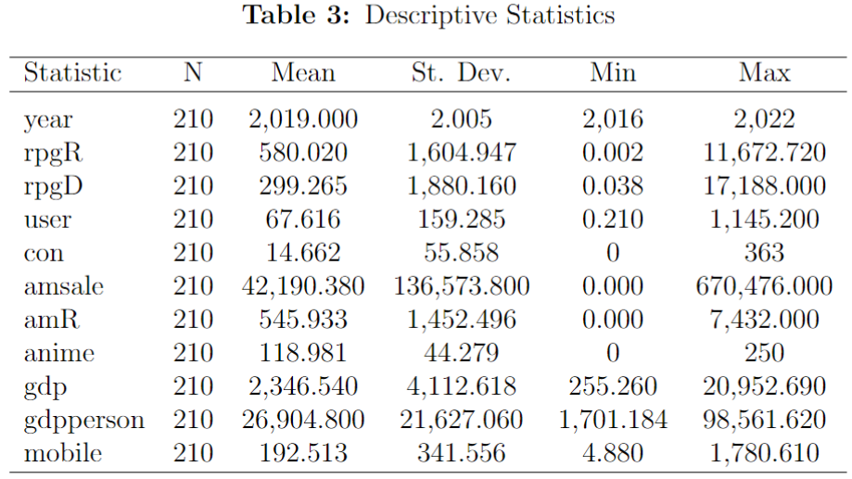

## 2.2 Strengths and Weaknesses of the Data

The data sources offer a robust mix of the otaku culture presence (con, amsale, amR, and anime), mobile RPG market (rpgR and rpgD), and economic indicators (gdp, gdpperson, mobile). It allows for a nuanced analysis of the otaku culture’s impact on the mobile RPG gaming sector. The panel data includes both the time and country, and also includes the continent level.

This study uses anime and manga market metrics as a proxy for the otaku culture, in which those people are more likely to enjoy the games with similar aspects of anime/manga elements. The focus is on correlating anime/manga market dynamics with the mobile RPG revenues or RPG download, with less amplified individual spending habits, and ignores consumer psychology to a certain extent. Giving fewer explanations of the otaku behaviors but more direct correlation between indicators and a tangible relationship.

The sources of raw data are from trustworthy statistical websites and market reports. However, some flaws exist. However, the study acknowledges limitations such as potential underreporting, due to the intellectual property and piracy issues, so some unobserved data would not be collected. Also, some data remains elusive because of various governmental restrictions on data disclosure due to their tiny market size, which could lead to gaps or skewed information.

## 2.3 Control Variables

We control for potential confounders, such as GDP and mobile penetration. Higher GDP and mobile penetration rates will naturally boost game app downloads and revenue since more purchasing power and app accessibility, and these variables should be controlled in subsequent analyses. Furthermore, a mere correlation between the otaku culture and mobile RPG popularity does not imply an exact causation. Other external factors, like active mobile users, are influential since they prefer to spend more time and money on app playing.

Some unobserved country-specific or time-specific factors will differ from the model's outcome. Different countries’ cultural attitudes toward gaming and social networks can also affect the popularity of games. If a game becomes popular within a certain country, it can spread rapidly through word of mouth, which can be a significant factor in its overall success. Also, the average age of the population (younger populations might be more inclined to play games), and even regulatory factors like policies that could affect the availability of certain games. Additionally, attractions in gaming can fluctuate over time due to various reasons, for instance, technological improvement such as AI interaction, lifespans in game playing, and changes in consumer preferences.

## 2.4 Factors in Model

The model factors in both primary variables of interest, such as the number of anime/manga conventions, market sales and revenues of anime/manga, and the number of anime releases, and control variables like GDP, GDP per capita, and mobile cellular subscription.

The otaku culture’s influence is measured using a series of variables, as discussed above. The number of anime/manga conventions in a country can be seen as a measure of how frequently people prefer to celebrate events in the otaku community. The market sales and revenues of anime/manga give a picture of economic benefit and financial success to this culture. Moreover, the anime accessibility reflects how open enthusiasts would like to pay for online channels for watching anime.

On the RPG mobile gaming side, we use the revenue or downloads as the dependent variable for popular RPG mobile games, directly correlated with a game genre popularity. The number of active mobile users serves as an indicator of sustained interest and engagement with these games.

Furthermore, control variables include macroeconomic indicators and other covariates that can influence the RPG mobile game revenue. For example, a country’s GDP or GDP per capita can indicate the populace’s disposable income, which in turn could affect their spending on mobile games. Also, the number of mobile cellular subscriptions can indicate the trend of how many people will actively use smartphones with registered phone numbers. Most mobile RPG games ask for phone numbers to register for their payment accounts.

Models also account for country-specific unobserved effects, which might encompass cultural nuances, regulatory frameworks, or any other factors affecting both the otaku culture and mobile gaming. Time-fixed effects capture global trends or shocks that affect all countries similarly during specific periods, such as advancements in mobile gaming technology or global economic downturns. Lastly, the error term represents the error term, capturing all other unexplained variations in the model.

# **Model and Estimation Technique**

This research applies two fixed-effects models to examine a correlation between the mobile RPG market revenue or downloads and the entrenchment of the otaku culture in a country. Depending on the scope and focus of this study, it is more beneficial to keep the model simpler to ensure that the primary relationships are clearly understood and the results are interpretable. The research question is centered around the cultural impact on the mobile RPG market, with the emphasis on consumer behavior, market trends, and cultural influences, rather than macroeconomic indicators. The concept of diminishing returns to GDP is not directly relevant. Including it will divert attention from the main cultural and economic factors for analyzing. In essence, these models provide a relatively comprehensive analytical framework to study the interplay between the otaku culture and the revenue of RPG mobile games, while also accounting for other significant influencing factors.

Linear and exponential models are well-suited to exploring relationships where we expect a proportional or escalating impact of one variable on another. These models can effectively capture the potential proportional (linear) or increasing (exponential) influence of otaku culture factors (like anime/manga popularity) on RPG game popularity. Through the observation of each two variables' relations in appendix A, some variables, such as anime conventions and anime accessibility, do not have a direct linear relationship to the RPG revenue and download. There exist clues that the increasing rate makes the exponential models appropriate. Linear models are straightforward and easy to interpret, making them ideal for communicating findings to an audience that may not have advanced statistical knowledge. Exponential models, while slightly more complex, are still relatively interpretable and can provide insights into more nuanced relationships responding to changing rates.

## 3.1 Linear Model

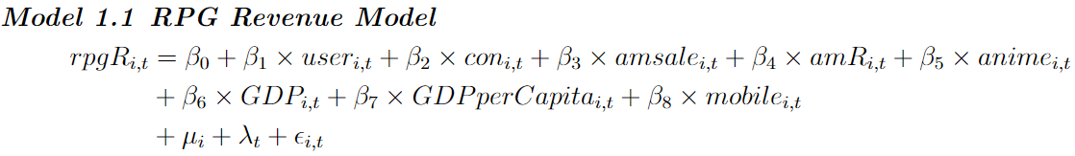

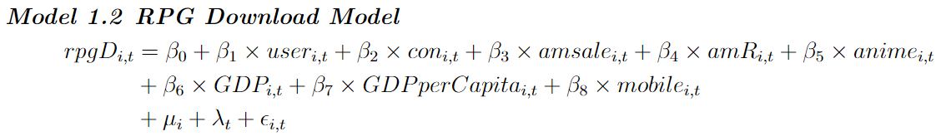

The linear models test the change in the otaku culture presence, reflected in anime/manga conventions, sales, revenue, and anime accessibility, will proportionally affect the mobile RPG mobile game revenue (Model 1.1) and downloads (Model 1.2). The otaku culture is represented by anime/manga conventions (), anime/manga sales and revenue ( and , respectively), and anime accessibility (). The RPG game's popularity is shown by RPG revenue () or RPG Download (). Country-effects and time-effects are captured by and respectively. The error term is Control variables are active mobile players (), GDP and GDP per capita, and mobile cellular subscription ().

## 3.2 Exponential Model

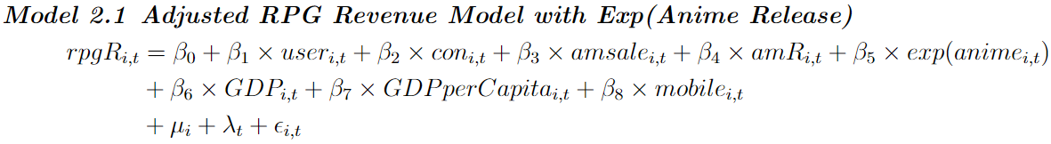

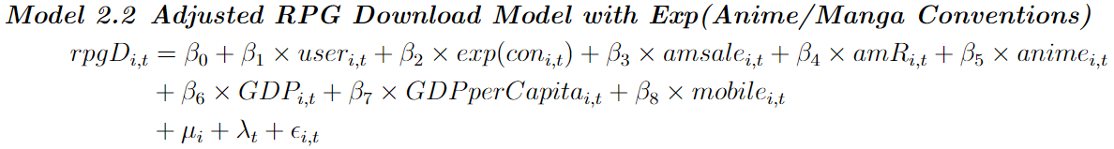

The expression in the above models, in Model 2.1 and in Model 2.2, refers to the exponential transformation of those variables (Appendix B and C). This transformation is used to capture a multiplicative or exponential relationship between the regressors and the regressive. The exponential models suggest that the impact of the otaku culture on the mobile RPG game success is non-linear, where changes in anime/manga conventions and anime accessibility provide a changing incremental effect on game market revenue and downloads.

For Model 2.1, if is significantly greater than 1, this could imply that increases at an increasing rate as the number of anime accessibility increases. If exactly equals 1, then the number of has a proportional effect on . If is less than 1 but positive, then increase at a decreasing rate as the number of increases. If is negative, then it would suggest that an increase in is associated with a decrease in , which would be counterintuitive and likely warrant further investigation into the data or model specification. The same explanation for in Model 2.2.

# **Results**

The linear regression results in Table 3 model 1 below indicate that anime/manga conventions and anime accessibility have a negative impact on RPG revenue. This counterintuitive finding suggests that while the otaku culture fosters hosting events and releasing more anime, other factors inhibit revenue growth in RPG games. Those factors will be some alternative forms of engagement or consumption, such as travel expenditure on attending conventions, paying event tickets, and network bills from watching anime, within the otaku community. This outcome indicates that while increases in anime/manga conventions and content accessibility are intuitively expected to drive up RPG revenues and downloads, other competing forms of engagement within otaku culture may dilute this effect. The negative coefficients associated with these variables in the linear regression model challenge traditional assumptions about the direct economic benefits of cultural popularity.

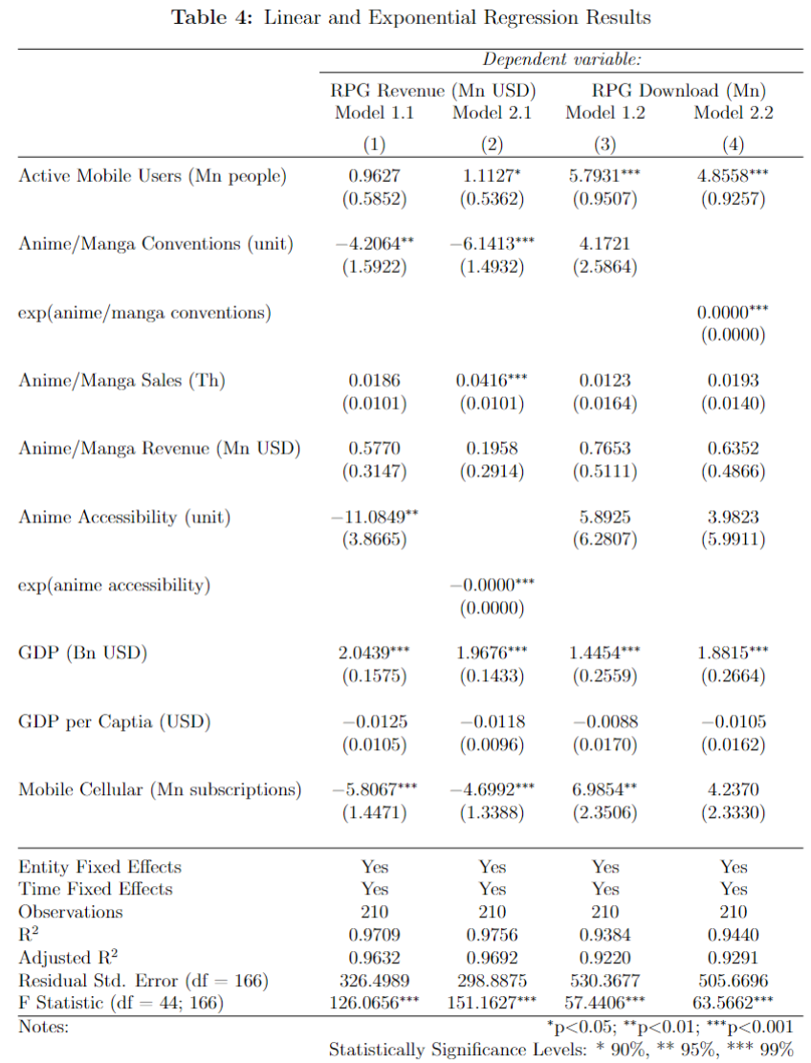

## 4.1 Findings

With a higher R-squared value, the exponential models better capture the complexities of the relationships. The exponential regression results in Table 3 model 2 above reflect higher R-squared value compared to those in linear regression ones, which indicates that selected independent variables have a stronger explanatory power to explain the variation of the dependent variable. The transformed variable for conventions in the RPG download model (Model 2.2) indicates a statistically significant impact, which contrasts with the linear model. The finding reveals that hosting more conventions is subject to diminishing returns on RPG downloading. This suggests a saturation point beyond which additional engagement in this culture community does not translate into proportionally higher downloads within the given data range. The presence of exponential terms in these models accentuates the non-linear dynamics at play, reflecting the nuanced ways in which otaku culture contributes to digital consumption patterns.

The differences between the linear and exponential models’ results suggest that the relationship between the otaku culture and the mobile RPG games is not straightforward. The presence of exponential terms indicates that factors such as anime/manga sales do not statistically significantly affect the RPG revenue in a linear manner. The latter incorporates exponential transformations of certain variables, suggesting a more complex, non-linear interaction. This complexity is indicative of the intricate ways in which cultural phenomena like the otaku culture intersect with consumer behavior and psychology, especially in digital marketplaces where many variables interact simultaneously. A variety of factors, including market saturation, varying willingness of engagement with the otaku culture, or other competing entertainment options can reduce the expected impact. Case in point, thinking about the indifference curves, RPGs serve as a combo with another good like a convention ticket. People who purchase the ticket to attend events probably will not spend money on games but have no negative effects on free-download game apps, following the results of both linear and exponential models.

Furthermore, the changes in coefficients for some variables in the revenue could be a result of multicollinearity in Figure 1 below or indicate that other unmeasured variables are influential. Anime/manga sales and Anime/manga revenue are highly correlated, which bring issues of OVB if run models without including one of them. However, the positive association of GDP across models implies that broader economic prosperity also plays a crucial role in the success of RPG mobile games.

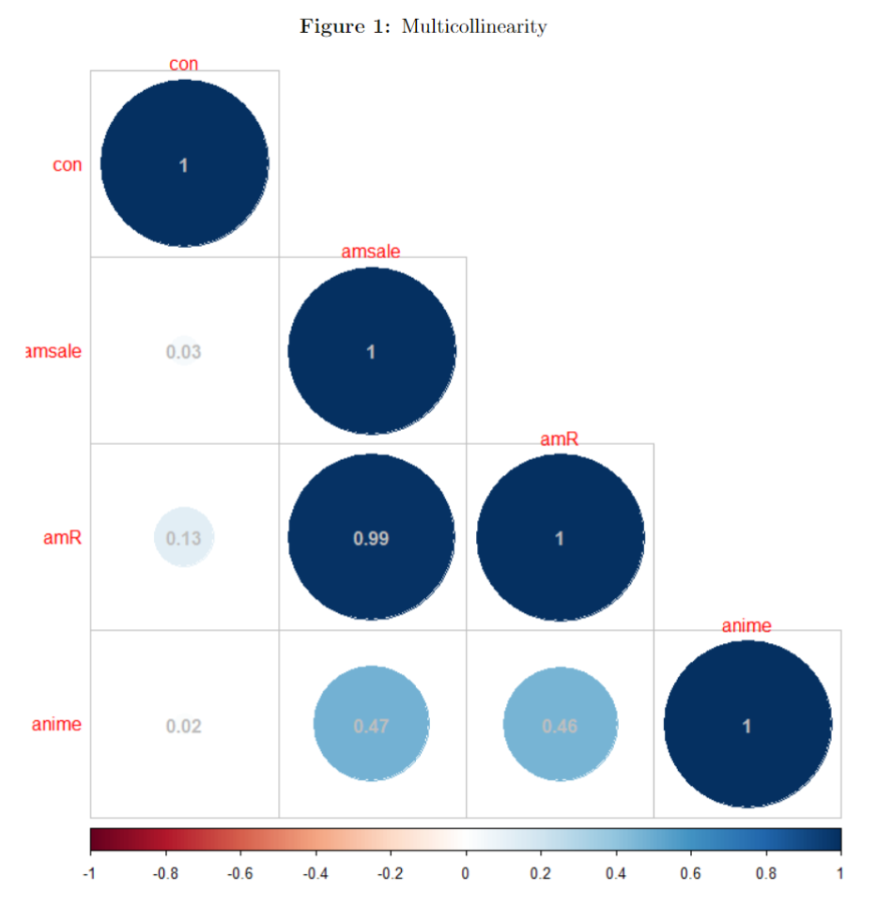

# **Conclusions**

The research concludes that the otaku culture’s influence on the mobile RPG market is a complex interplay between cultural, economic, and technological factors in shaping consumer behavior in the mobile gaming industry. The findings could prompt further investigation into how other uncaptured aspects of the otaku culture contribute to economic outcomes within the gaming industry. Exploring how market dynamics, such as local GDP and tech environment, in a specific region like one country or continent, influence the popularity and revenue of RPG mobile games. Understanding these dynamics is crucial for game developers and marketers as they navigate the otaku marketplace. It emphasizes the need for strategies that are responsive to the complexity of consumer behavior and the cultural contents that shape these behaviors. Offering insights into how game developers can tailor their products to better resonate with the otaku culture and speculating on future trends, rather than relying on broad assumptions about the positive impact of cultural affinity on economic performance. The study, despite its acknowledged limitations on data restrictions, offers significant insights into the economic effects of cultural trends on the digital entertainment industry. It provides a foundation for future research and practical applications in market strategy development.

In conclusion, the study underscores the need for a nuanced understanding of consumer behavior and cultural impact within the digital entertainment space. For industry practitioners, these insights are crucial for developing marketing strategies and product offerings that resonate with the multifaceted consumer preferences influenced by the otaku culture. For academics, the research highlights the importance of employing diverse analytical methods, other than quantitative regression, to capture the complex realities of cultural economics in the digital age. Future research should continue to explore these relationships, possibly addressing the identified data gaps and incorporating qualitative measures of consumer engagement to provide a more holistic view of the otaku or other similar cultures' economic impact.

# **References**

Adams, M. J. (2022). Tech Otakus Save the World? Gacha, Genshin Impact, and Cybernesis. *British Journal of Chinese Studies*, *12*(2), 199–208.<https://doi.org/10.51661/bjocs.v12i2.199>

Blake, S. (2023, July 25). Genshin Impact Revenue and Usage Statistics (2023). *Mobile Marketing Reads*.<https://mobilemarketingreads.com/genshin-impact-revenue-and-usage-statistics-2020/>

Chapple, G. (2021). Genshin Impact Generates $2 Billion on Mobile in First Year. *Sensor Tower.*<https://sensortower.com/blog/genshin-impact-mobile-two-billion-revenue>

Garg, S. (2019). From Pronoun to Identity: Tracing the History of the Word Otaku. *Journal of Arts, Culture, Philosophy, Religion, Language and Literature*, *3*(1), 21–23.<https://www.researchgate.net/publication/334491036_From_Pronoun_to_Identity_Tracing_the_History_of_the_Word_Otaku>

Hernández-Pérez, M. (2019). Looking into the “Anime Global Popular” and the “Manga Media”: Reflections on the Scholarship of a Transnational and Transmedia Industry. *Arts*, *8*(2), 57.<https://doi.org/10.3390/arts8020057>

Hills, M., & McGregor, E. (2002). *Transcultural otaku: Japanese representations of fandom and representations of Japan in anime/manga fan cultures*.<https://cmsw.mit.edu/mit2/Abstracts/MattHillspaper.pdf>

Kam, T. H. (2013). The common sense that makes the ‘otaku’: Rules for consuming popular culture in contemporary Japan. *Japan Forum*, *25*(2), 151–173.<https://doi.org/10.1080/09555803.2012.743481>

Knipp, P. J., Walker, K. R., Durney, K., & Perez, J. E. (2015). Public and Academic Library Collaboration Through an Anime and Comics Enthusiasts Convention (ACEcon). *Journal of Library Innovation*, *6*(2), 73–88.<https://www.proquest.com/docview/1770382932/citation/C736A13D83774F3CPQ/1>

Lamarre, T. (2018). *The Anime Ecology: A Genealogy of Television, Animation, and Game Media*. U of Minnesota Press.<https://books.google.com/books?id=aCp0DwAAQBAJ>

Matusitz, J., & Payano, P. (2012). Globalisation Of Popular Culture: From Hollywood To Bollywood. *South Asia Research*, *32*(2).<https://doi.org/10.1177/026272801245397>

Niu, H.-J., Chiang, Y.-S., & Tsai, H.-T. (2012). An Exploratory Study of the Otaku Adolescent Consumer. *Psychology & Marketing*, *29*(10), 712–725.<https://doi.org/10.1002/mar.20558>

Patrick, M., & Wonkyu, S. (2017). The Success of K-pop. *Asian Journal of Social Science*, *45*(4–5).<https://brill.com/view/journals/ajss/45/4-5/article-p409_3.xml>

Pookulangara, S., Kinley, T., Josiam, B., & Spears, D. (2013). Hollywood and fashion: Influence on apparel purchase decisions. *International Journal of Sales, Retailing & Marketing*, *2*(1), 50–63.https://www.researchgate.net/publication/257527697_Hollywood_and_fashion_influence_on_apparel_purchase_decisions

Zhang, R., Chang Bi, N., Kodzi, P., Goodwin, A., Wasilewski, K., & McCurdy, E. (2020). From K-pop to Korean products: An investigation into the mediating effects of imitation and attitudes toward Korean culture and products. *Journal of Cultural Marketing Strategy, 5(1), 36–48.* [*https://www.ingentaconnect.com/content/hsp/jcms/2020/00000005/00000001/art00005*](https://www.ingentaconnect.com/content/hsp/jcms/2020/00000005/00000001/art00005)

*Beyond 2021: Where does gaming go next? Asia-Pacific gaming market and consumer research repor*. (2021). *Newzoo.*

*Key Insights into Role-Playing Games (RPGs) The games, the players, and the markets*. (2022). *Newzoo.*

*Global Mobile Market Report Key Trends | Market Sizing & Forecasts Special Focus Topic | Rankings*. (2021). *Newzoo.*

# **Appendix**

## A

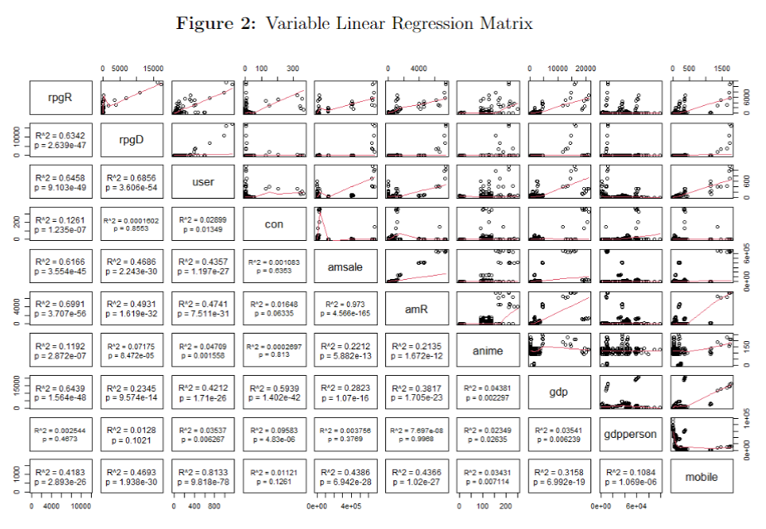

## **B**

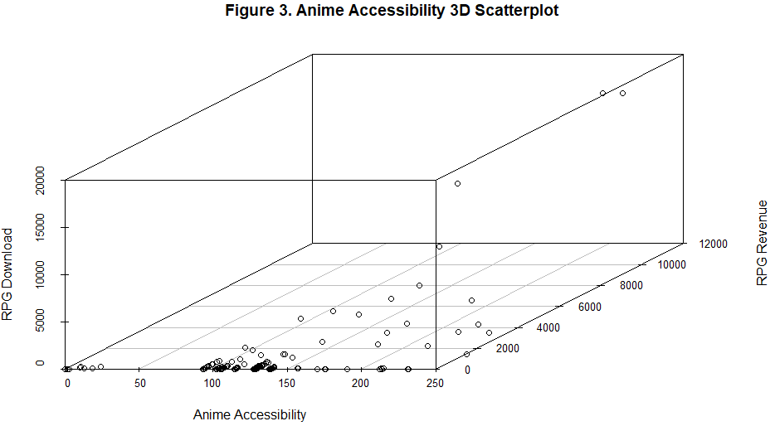

Anime accessibility is much more correlated to RPG revenue with more scatters close to x-y surface.

X-axis: Anime Accessibility

Y-axis: RPG Revenue

Z-axis: RPG Download.

## **C**

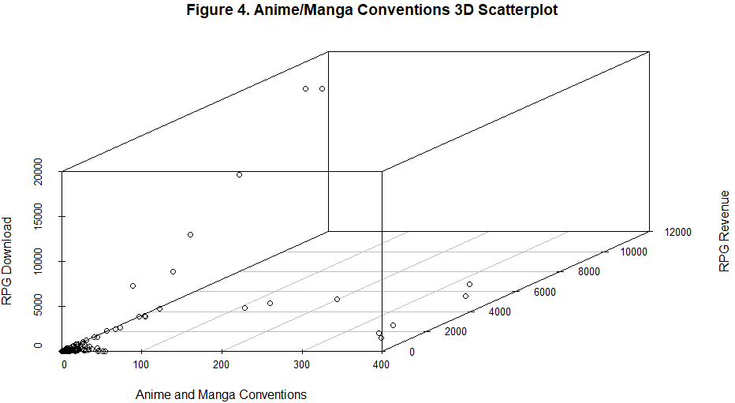

Anime conventions are more correlated to RPG download with more scatters close to x-z surface.

X-axis: Anime and Manga Conventions

Y-axis: RPG Revenue

Z-axis: RPG Download.